**Phase 1 Report**

**Electricity Prices Prediction**

**Phase 1: Problem Definition and Design Thinking**

**Problem Definition:**

 The problem is to develop a predictive model that uses historical electricity prices and relevant factors to forecast future electricity prices.

The objective is to create a tool that assists both energy providers and consumers in making informed decisions regarding consumption and investment by predicting future electricity prices.

This project involves data preprocessing, feature engineering, model selection, training, and evaluation.

**Design Thinking:**

1. **Data Source:**

Utilize a dataset containing historical electricity prices and relevant factors like date, demand, supply, weather conditions, and economic indicators.

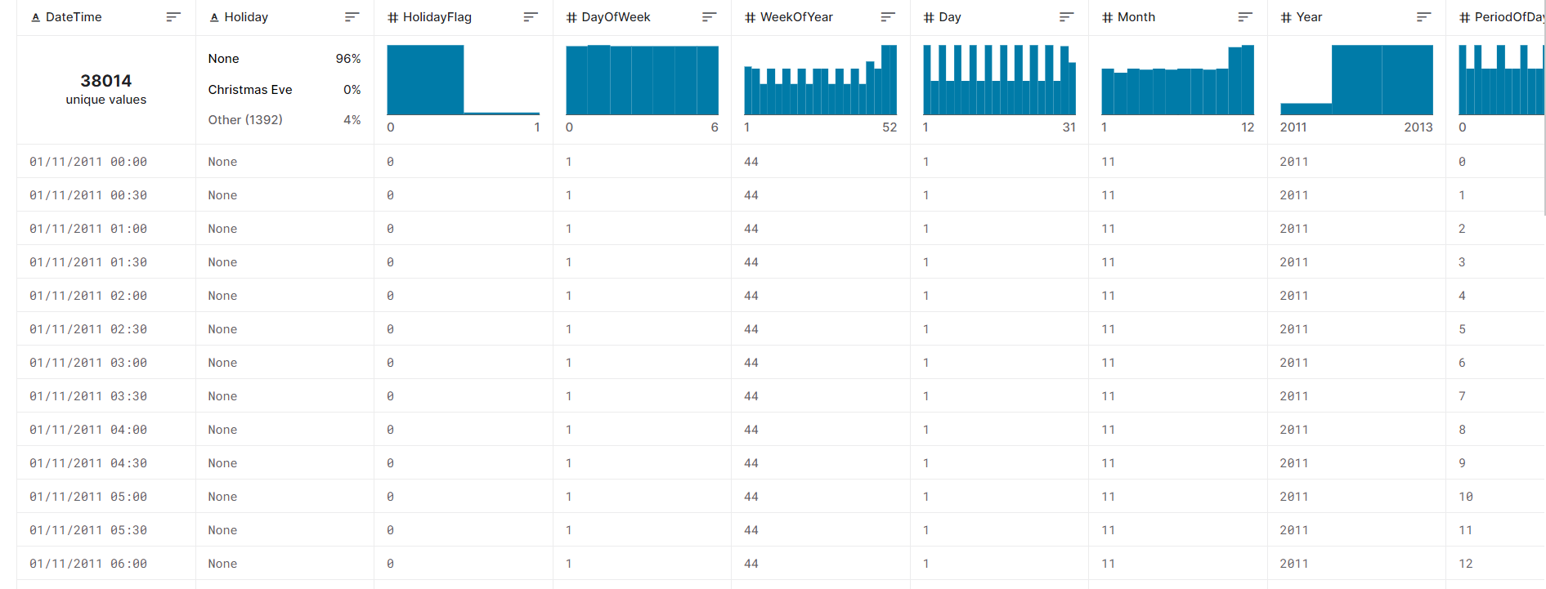

**2.Data Preprocessing:**

Clean and preprocess the data, handle missing values, and convert categorical features into numerical representations.

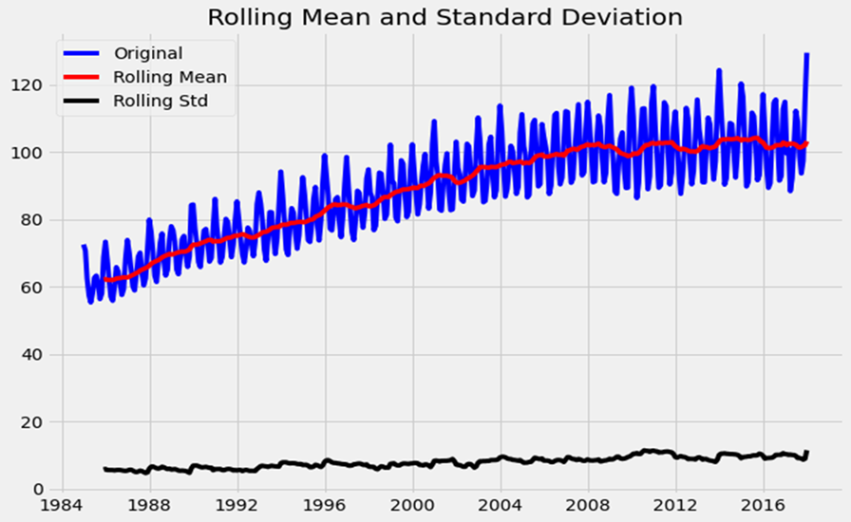l

**3.Feature Engineering:**

Create additional features that could enhance the predictive power of the model, such as time-based features and lagged variables.

**4.Model Selection:**

Choose suitable time series forecasting algorithms (e.g., ARIMA, LSTM) for predicting future electricity prices.

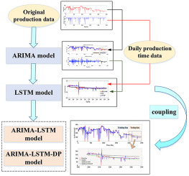

**5.Model Training:**

Train the selected model using the preprocessed data.

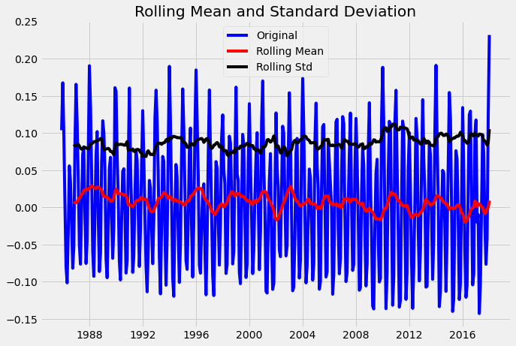

**6.Evaluation:**

Evaluate the model's performance using appropriate time series forecasting metrics (e.g., Mean Absolute Error, Root Mean Squared Error).

MAE = 1/n * sum(abs(actual - predicted))

RMSE = sqrt(1/n * sum((actual - predicted)^2))

7. **Visualization Selection:**

Determine suitable visualization types (e.g., bar charts, pie charts, heatmaps) to represent demographic distributions effectively.

